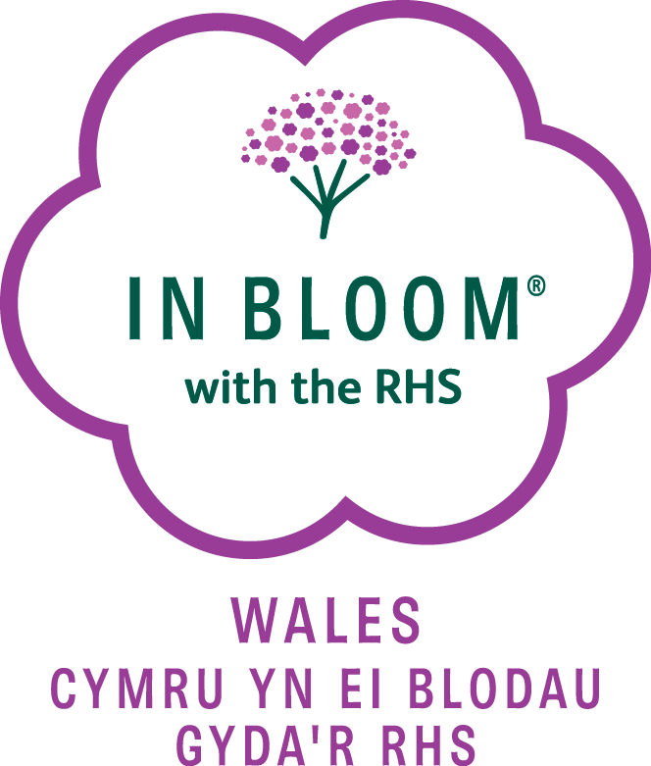

**Wales in Bloom**

**- How to get involved ….**

​

**Sponsorship for Categories**

We are continually seeking `sponsorship’ for our `Wales in Bloom’ Categories – if you know of any organisations who may be interested in sponsoring one of our Categories on an annual basis, please ask them to contact us.

We thank you for your continued support and look forward to hearing from you.

E-mail us : [campaign@walesinbloom.co.uk](mailto:campaign@walesinbloom.co.uk)